HOSPITAL APPOINTMENT BOOKING SYSTEM

TABLE OF CONTENTS
- Abstract
- Introduction
- Problem Statement
- Objectives of the Project
- Scope of the Project
- Literature Survey
- Existing System
- Proposed System
- System Architecture
- System Flow Diagram
- ER Diagram
- Database Design
- Module Description
- Technology Stack
- API Design
- User Interface Design
- Testing
- Advantages of the System
- Limitations
- Future Enhancements
- Conclusion
- References

- ABSTRACT
The Hospital Appointment Booking System is a comprehensive web-based application designed to automate and streamline the process of scheduling medical appointments in hospitals and healthcare centers. In many traditional hospital environments, appointment management is still handled through manual registers or partially digital systems. These approaches often result in long patient waiting times, appointment overlaps, poor resource utilization, and administrative inefficiencies.
This project aims to overcome these challenges by providing a centralized, user-friendly platform that efficiently connects patients, doctors, and hospital administrators. The system allows patients to register securely, log in, and book appointments with doctors by selecting the appropriate department, available doctors, and preferred time slots. By offering real-time availability information, the system minimizes scheduling conflicts and improves patient convenience.
Doctors are provided with a dedicated dashboard where they can view their scheduled appointments, manage availability, update consultation status, and access patient appointment details. This helps doctors plan their schedules effectively and ensures better patient flow management within the hospital.
Administrators play a key role in maintaining the system. Through the admin module, hospital staff can manage doctor profiles, patient records, department information, and appointment schedules. Administrators can monitor overall system activity, generate reports, and ensure smooth coordination between patients and doctors.
From a technical perspective, the backend of the system is developed using Java Spring Boot, which provides robust support for RESTful APIs, security, scalability, and transaction management. Spring Boot ensures efficient handling of concurrent users and smooth integration with the database. The frontend is developed using Angular, enabling a responsive and dynamic user interface with seamless navigation and real-time data updates.
Overall, the Hospital Appointment Booking System enhances operational efficiency, reduces manual effort, improves patient experience, and ensures better healthcare service delivery. The system is scalable, secure, and can be extended in the future to include features such as online payments, notifications, electronic medical records, and analytics, making it suitable for modern healthcare institutions.
- INTRODUCTION
Healthcare institutions such as hospitals and clinics require efficient and reliable systems to manage patient appointments and ensure smooth patient flow. In many traditional hospital environments, appointment scheduling is still handled using manual registers or basic semi-digital systems. These methods often result in long waiting times, appointment overlaps, data inconsistencies, and inefficient utilization of medical resources, which negatively impact both patients and healthcare providers.

Manual appointment systems make it difficult to maintain accurate records, especially when handling many patients daily. Changes such as appointment cancellations, rescheduling, or doctor unavailability are not updated in real time, leading to confusion, overcrowding, and poor patient experience. Additionally, administrative staff spend a significant amount of time managing appointments manually, increasing the chances of human error and operational delays.

The Hospital Appointment Booking System addresses these challenges by introducing a fully digital, web-based solution that automates the appointment scheduling process. The system enables patients to book appointments online by selecting departments, doctors, and available time slots, ensuring transparency and convenience. Real-time appointment management helps prevent scheduling conflicts and reduces patient waiting time within the hospital.

From the hospital’s perspective, the system improves workflow efficiency by providing doctors with clear schedules and allowing administrators to monitor appointments, patient records, and doctor availability through a centralized platform. By reducing manual intervention, the system enhances data accuracy, improves operational efficiency, and supports better decision-making.

Overall, the Hospital Appointment Booking System improves the quality of healthcare services by offering a reliable, scalable, and user-friendly appointment management solution. It ensures better coordination between patients, doctors, and hospital administrators, making it highly suitable for modern healthcare institutions and aligned with the objectives of digital transformation in healthcare.
- PROBLEM STATEMENT
In many hospitals today, the process of booking medical appointments continues to rely heavily on manual or partially digital systems. Despite advances in information technology and the increasing push toward digital transformation in healthcare, numerous healthcare institutions—especially those in semi-urban and rural regions—still depend on outdated methods of managing patient appointments. This often involves requiring patients to physically visit the hospital to register, verify their details, and schedule an appointment with a doctor. Such a system not only causes inconvenience but also leads to inefficiencies that affect both patients and healthcare providers.

For patients, particularly elderly individuals, people with disabilities, those suffering from chronic illnesses, and individuals residing in distant or rural areas, the need to travel to the hospital solely to book an appointment creates unnecessary physical, financial, and emotional strain. Long travel times, transportation challenges, and increased costs make the process burdensome. Upon reaching the hospital, patients often face long queues at registration counters and extended waiting times due to overcrowding. These delays can be especially distressing for individuals who require timely medical attention. As a result, the overall patient experience becomes unsatisfactory, leading to frustration, fatigue, and in some cases, delayed or missed treatments.

From the hospital’s perspective, the continued reliance on manual appointment booking creates significant administrative challenges. Staff members spend substantial time maintaining handwritten or semi-digital appointment logs, which are prone to mistakes such as double entries, illegible handwriting, or misplaced documents. The absence of a centralized and automated tracking system also results in scheduling conflicts, such as overlapping appointments or incorrect time allocations, which disrupts doctors' schedules and decreases operational efficiency. Physicians may experience uneven workloads, with some time slots overcrowded and others underutilized, simply due to disorganized appointment planning.

Furthermore, manual documentation increases the likelihood of data inconsistency and human error. Patient details recorded manually may contain inaccuracies, leading to incorrect medical records, communication gaps, or delays in service delivery. Paper-based systems face additional risks of physical damage, such as tearing, loss of files, or deterioration over time, which compromises the reliability of patient data. Lack of integration across departments means that staff must repeatedly verify or re-enter information, further raising the risk of errors and inefficiencies.

The absence of real-time data updates is another major drawback of traditional appointment systems. When appointments are booked manually, doctors and administrative staff have limited visibility into the current status of appointments, cancellations, or rescheduling requests. This lack of dynamic information flow prevents hospitals from optimizing resource allocation, predicting patient flow, and ensuring timely communication between staff and patients. Ultimately, it affects the hospital’s ability to deliver organized, patient-centered healthcare services.

Given these challenges, there is a pressing and undeniable need for a robust, automated, and user-friendly hospital appointment management system. Such a system should enable patients to book appointments remotely through digital platforms such as mobile applications or web portals, reducing the need for physical visits and minimizing waiting times. Automation would streamline hospital operations by ensuring accurate, real-time updates of schedules, preventing overlapping appointments, and enhancing coordination among staff.

An effective digital appointment system would also improve data accuracy by maintaining secure electronic records, reducing the risk of document loss, and ensuring consistent patient information across departments. Additionally, automated reminders and notifications can help patients keep track of upcoming appointments, reduce no-show rates, and improve overall healthcare outcomes.

- OBJECTIVES OF THE PROJECT
Here’s a fully elaborated version of your Objectives of the Hospital Appointment Booking System section, expanded to about two pages of content:
Objectives of the Project.
The primary objective of the Hospital Appointment Booking System is to automate and simplify the appointment scheduling process in healthcare institutions. In modern healthcare, efficiency, accuracy, and patient satisfaction are critical. Traditional methods of appointment booking, which often rely on manual paperwork and in-person scheduling, are prone to delays, errors, and inefficiencies. By introducing a web-based system, hospitals can streamline their operations, reduce administrative burdens, and enhance the overall patient experience. The following specific objectives highlight the scope and importance of this project.

1.1 Automating the Hospital Appointment Booking Process

One of the central goals of the project is to replace manual scheduling with a fully automated, web-based system. Patients can book appointments online at their convenience, without needing to physically visit the hospital or call reception desks. Automation ensures that appointments are recorded instantly, reducing the risk of double-booking or miscommunication. This objective also supports scalability, as hospitals can handle a larger volume of patients without overwhelming staff. Furthermore, automation allows integration with other hospital systems, such as electronic health records (EHRs), ensuring seamless coordination between departments.

1.2 Reducing Patient Waiting Time

Long waiting times are a common source of frustration for patients in healthcare facilities. By enabling online appointment scheduling, patients can select available time slots that suit their schedules, minimizing unnecessary delays. The system can also send reminders and notifications to patients, reducing missed appointments and improving punctuality. This objective directly contributes to patient satisfaction, as individuals feel their time is valued and
respected. In addition, reduced waiting times help hospitals manage patient flow more effectively, preventing overcrowding in waiting areas and ensuring smoother service delivery

1.3 Improving Hospital Workflow Efficiency

Efficient workflow is essential for hospitals to deliver quality healthcare services. A systematic appointment management system ensures that doctors, nurses, and administrative staff have clear visibility into daily schedules. This reduces confusion, improves coordination, and allows healthcare providers to allocate resources more effectively. For example, doctors can prepare for upcoming consultations in advance, while administrative staff can manage patient queues with greater accuracy. By streamlining operations, hospitals can focus more on patient care rather than administrative tasks, ultimately improving the overall quality of healthcare services.

1.4 Providing Secure, Accurate, and Reliable Data Storage

Data security and reliability are critical in healthcare, where sensitive patient information must be protected. The Hospital Appointment Booking System aims to provide secure storage for patient and appointment data, ensuring compliance with privacy regulations and safeguarding against unauthorized access. Accuracy in data storage also minimizes errors, such as incorrect patient details or appointment times. Reliable data management supports long-term record-keeping, enabling hospitals to track patient histories, monitor appointment trends, and generate reports for decision-making. This objective strengthens trust between patients and healthcare institutions, as individuals are assured that their personal information is handled responsibly.

1.5 Eliminating Manual Paperwork and Minimizing Human Errors

Manual paperwork is not only time-consuming but also prone to mistakes such as misplaced files, illegible handwriting, or incorrect entries. By digitizing the appointment booking process, hospitals can eliminate these inefficiencies. The system reduces reliance on physical records, making information retrieval faster and more accurate. Automated validation features can prevent common errors, such as booking overlapping appointments or entering incomplete patient details. Minimizing human errors enhances the reliability of hospital services and reduces administrative costs associated with correcting mistakes or managing paper records.

- SCOPE OF THE PROJECT
In many healthcare institutions, particularly in developing regions, the process of booking hospital appointments remains largely manual or only partially digital. Despite significant advancements in health information systems and digital technologies, several hospitals still rely on outdated procedures for managing patient registrations and doctor appointments. These traditional methods typically involve patients physically visiting the hospital to stand in queues, fill out forms, and wait for available slots. While this approach may have been adequate in earlier years, it has become increasingly inefficient and unsuitable for modern healthcare environments, where speed, accuracy, and convenience are critical.

For patients, especially those who are elderly, chronically ill, physically challenged, or living in remote rural areas, the requirement to travel to the hospital solely to schedule an appointment creates significant inconvenience. Many of these individuals struggle with mobility issues, lack of transportation, high travel expenses, and long waiting times at registration counters. The situation becomes more difficult during peak hours, when hospitals experience high patient flow. Long queues and extended waiting periods contribute to stress, fatigue, and discomfort, particularly for those already experiencing health issues. As a result, many patients become discouraged from seeking timely medical care, which can lead to worsening health conditions and delayed treatments.

Additionally, the current manual process often lacks transparency and real-time information. Patients do not have visibility into a doctor’s availability until they reach the hospital. If appointments for the day are already filled, they are forced to return home and come back another day, which wastes time and resources. This lack of predictability and convenience reduces overall patient satisfaction and undermines the quality of healthcare service delivery.
From the hospital’s administrative perspective, manual appointment booking creates significant operational challenges. Hospital staff must maintain handwritten logs, update registers, and verify patient details repeatedly. These processes are highly prone to human errors such as illegible handwriting, misplaced forms, incorrect data entry, and duplicate records. Such inaccuracies can lead to scheduling conflicts, miscommunication between departments, and inefficient resource utilization. Doctors may face overlapping appointments, uneven patient loads, or underutilized time slots, all of which hinder smooth workflow and reduce productivity.
The absence of a centralized and automated appointment management system also makes it difficult for hospitals to maintain accurate patient records. Paper-based documents are vulnerable to physical damage, loss, or deterioration over time. Retrieving past appointment histories, updating records, or cross-referencing patient data becomes a time-consuming task. Without a real-time digital record system, coordination between doctors, nurses, reception staff, and administrative teams becomes slow and fragmented. This leads to delays in patient care, inconsistencies in information, and an overall reduction in operational efficiency.

Moreover, manual systems lack features such as automated reminders, cancellation tracking, and remote access, all of which are essential in modern healthcare environments. Without real-time communication, patients may forget scheduled appointments, contributing to high no-show rates that disrupt hospital schedules. Doctors are often unaware of last-minute cancellations or changes, leading to idle time or uneven patient distribution. This inefficiency impacts both staff performance and patient satisfaction.

The growing demand for accessible, efficient, and patient-centric healthcare highlights the urgent need for digital transformation in appointment management. An automated hospital appointment system would allow patients to conveniently schedule appointments through a website or mobile application, reducing the need for physical visits. Such a system would display available time slots, doctor availability, and estimated waiting times, enabling patients to make informed decisions. For hospital administrators, an automated system would ensure accurate, centralized, and real-time management of schedules, minimize human errors and ensure streamlined operations.

Furthermore, digital appointment systems improve data integrity by maintaining secure electronic records, reducing paperwork, and enabling efficient data retrieval. Features such as SMS or app-based reminders help reduce no-show rates and promote better patient adherence to medical follow-ups. Doctors benefit from a well-organized schedule, updated appointment lists, and improved coordination with hospital staff.

- LITERATURE SURVEY

Hospital Management Systems (HMS) have been widely deployed across healthcare institutions to support administrative, clinical, and financial operations. A review of existing solutions indicates that the majority of available HMS platforms place significant emphasis on patient record management, billing automation, inventory control, and laboratory handling. While these components are essential for efficient hospital functioning, the module for appointment scheduling often receives comparatively less attention. As a result, many systems provide only basic or outdated functionalities for appointment booking, leading to difficulties in managing large volumes of patients effectively.

Although several online appointment booking systems exist in the market, most of them lack the flexibility required to handle real-world hospital workflows. Many traditional systems do not provide real-time updates, meaning that changes in doctor availability, cancellations, or emergency adjustments are not reflected immediately. When multiple patients attempt to book appointments concurrently, these systems fail to prevent double-booking or conflicts, creating disruption in both patient flow and doctor schedules.

In addition, a key weakness observed in many current solutions is the absence of role-based access control (RBAC). In a hospital environment, different users—such as administrators, doctors, receptionists, and patients—need different levels of access and permissions. However, several existing systems allow uniform access for all users or rely on weak authentication mechanisms. This leads to challenges such as unauthorized modifications, improper handling of sensitive records, and vulnerabilities in data security.

Another significant limitation in existing appointment systems is the lack of a centralized platform. Many of the currently used tools operate in isolation, meaning that patient data, doctor schedules, and administrative records are stored separately or managed manually. This fragmentation results in inefficiencies, inconsistent information, and delays in communication. For instance, an appointment booked online may not automatically update in the doctor’s internal schedule, creating confusion and operational errors.
Security and data consistency also emerge as critical concerns in the literature. Manual booking systems and poorly designed digital tools are prone to issues such as inconsistent record keeping, duplication of entries, and loss of data due to human error. The absence of centralized storage and reliable backup mechanisms further increases the risk of data mismanagement. Since appointment details directly affect patient care, any inconsistency can lead to scheduling issues, miscommunication, and reduced overall service quality.

Usability is another important aspect highlighted in surveys and studies. Many existing solutions are not intuitive or user-friendly, especially for elderly patients or users with limited technical knowledge. Complicated interfaces, non-responsive designs, and unclear navigation paths reduce user adoption and effectiveness. For healthcare environments, where quick access to accurate information is essential, systems must be easy to use and accessible across devices.

Considering these gaps, the proposed Hospital Appointment Booking System aims to deliver a comprehensive, secure, and efficient solution. It incorporates real-time appointment management, ensuring that all updates—such as bookings, cancellations, or modifications—are instantly reflected. This greatly reduces the chances of scheduling conflicts and enhances overall coordination among patients, doctors, and administrative staff.

The system includes secure authentication mechanisms supported by role-based access control, ensuring that each user interacts only with the functionalities relevant to their role. This enhances both security and workflow efficiency. For example, doctors can view their schedules and manage availability, administrators can oversee the entire system, and patients can book appointments without accessing sensitive internal data.

Furthermore, the proposed system prioritizes usability and reliability. It is designed with a user-friendly interface, providing easy navigation and quick access to essential features. By centralizing appointments, maintaining consistent records, and automating scheduling processes, the system minimizes human error and ensures higher service quality.

- EXISTING SYSTEM

The current hospital appointment system in many healthcare institutions is predominantly manual, relying on physical registers or basic software tools that lack automation and integration. While these methods have served hospitals for years, they are increasingly inadequate in meeting the demands of modern healthcare. The limitations of the existing system affect both patients and hospital staff, leading to inefficiencies, errors, and dissatisfaction. Below is a detailed discussion of the drawbacks associated with the existing system.

  - Manual Register-Based Appointment Booking

In most hospitals, appointments are booked manually by reception staff who record patient details in physical registers or simple spreadsheets. This process is slow, repetitive, and prone to human error. Handwritten entries can be illegible, and records are easily misplaced or damaged. Retrieving information from registers is also cumbersome, especially when dealing with large patient volumes. The lack of automation means that staff must spend significant time on administrative tasks rather than focusing on patient care. Moreover, manual systems make it difficult to track appointment histories or generate reports for hospital management.

  - Long Queues and Increased Patient Waiting Time

Patients often face long queues when booking appointments in person. This not only wastes valuable time but also creates frustration and dissatisfaction. In many cases, patients must arrive early to secure a slot, leading to overcrowding in hospital waiting areas. The inefficiency of the system contributes to delays in consultations, as doctors may not have a clear schedule prepared in advance. Long waiting times negatively impact patient experience and can discourage individuals from seeking timely medical care, which is particularly concerning in cases requiring urgent attention.

  - Lack of Online Access for Patients

The absence of online booking facilities is a major drawback of the existing system. Patients cannot schedule appointments remotely and must physically visit the hospital or call reception desks. This lack of convenience is especially problematic for elderly patients, individuals with mobility issues, or those living far from healthcare facilities. In today’s digital age, where online services are widely available in other sectors, the absence of online access in healthcare highlights the outdated nature of the existing system. It also limits hospitals’ ability to reach a broader patient base and provide flexible services.

  - High Possibility of Appointment Overlaps and Scheduling Conflicts

Manual systems are prone to scheduling conflicts, such as double-booking or overlapping appointments. Since records are updated manually, there is a higher risk of errors in time slot allocation. These conflicts disrupt hospital workflow, cause delays in consultations, and lead to dissatisfaction among patients. Doctors may face situations where multiple patients are scheduled at the same time, forcing staff to reschedule appointments and creating unnecessary confusion. Such inefficiencies reduce the credibility of hospital services and highlight the need for a more systematic approach.

  - Increased Dependency on Paperwork and Manual Record Maintenance

The reliance on paperwork is another significant limitation of the existing system. Maintaining physical records requires storage space, careful organization, and constant monitoring. Paper records are vulnerable to damage, loss, or unauthorized access. Additionally, updating and retrieving information from paper files is time-consuming and inefficient. Hospitals often struggle with maintaining accurate records, which can lead to errors in patient information and appointment details. The dependency on paperwork also increases administrative costs and reduces overall efficiency.

Impact of Limitations

These limitations collectively affect both patients and hospital staff. Patients experience long waiting times, lack of convenience, and poor service quality, while hospital staff face increased workloads, inefficiencies, and errors in scheduling. The overall impact is a reduction in hospital efficiency and patient satisfaction. In an era where healthcare institutions are expected to deliver fast, reliable, and patient-centred services, the existing system falls short of expectations. This highlights the urgent need for a modern, automated solution that can address these challenges and improve the quality of healthcare delivery.

- PROPOSED SYSTEM

The proposed Hospital Appointment Booking System is a web-based, centralized solution designed to overcome the limitations of the existing manual system. By leveraging modern technology, the system provides patients with the convenience of booking appointments online without physically visiting the hospital. It also ensures that hospital staff can manage appointments more efficiently, reducing errors and improving workflow. This system represents a significant step toward digital transformation in healthcare, offering both patients and hospitals a more reliable, transparent, and efficient appointment management process.

  - Centralized Web-Based Appointment Management

The system is built on a centralized platform that integrates all appointment-related data. This ensures that hospitals can manage patient bookings, doctor schedules, and departmental workflows from a single interface. Centralization eliminates duplication of records and provides real-time visibility into hospital operations. It also allows administrators to monitor appointment trends and generate reports for better decision-making.

  - Online Appointment Booking with Department-Wise Doctor Selection

Patients can access the system remotely through a web portal or mobile application. They can select the department they wish to visit and choose from available doctors based on specialization. This feature empowers patients to make informed decisions about their healthcare providers and reduces the need for physical visits to book appointments. It also enhances patient convenience, especially for those living in remote areas or with mobility challenges.

  - Real-Time Time Slot Availability

The system displays real-time availability of appointment slots, ensuring that patients can book appointments without conflicts. This feature eliminates the risk of double-booking or overlapping schedules, which is common in manual systems. Real-time updates also allow doctors and staff to plan their day more effectively, improving hospital workflow and reducing patient waiting times.

  - Secure Authentication and Role-Based Access Control

Security is a critical aspect of the proposed system. Patients, doctors, and administrators are provided with secure login credentials, ensuring that only authorized individuals can access sensitive data. Role-based access control ensures that users can only view or modify information relevant to their responsibilities. For example, patients can book appointments and view their records, while doctors can access their schedules and patient details. Administrators have broader access to manage hospital operations securely.

  - Efficient Management of Patients, Doctors, and Appointment Data

The system maintains structured records of patients, doctors, and appointments. This allows hospitals to store and retrieve information quickly and accurately. Patient histories can be linked to appointment records, enabling doctors to prepare for consultations in advance. Efficient data management also supports long-term record-keeping, compliance with healthcare regulations, and improved coordination between departments.

Benefits of the Proposed System
  - Improved Transparency in Appointment Scheduling

Patients can view available slots, doctor schedules, and booking confirmations in real time. This transparency builds trust between patients and hospitals, as individuals are assured that appointments are managed fairly and systematically. It also reduces disputes or confusion regarding appointment timings.

  - Reduced Patient Waiting Time

By allowing patients to book appointments online, the system minimizes the need for long queues and overcrowding in hospital waiting areas. Patients can arrive at the hospital at their scheduled time, reducing delays and improving their overall experience. This benefit directly addresses one of the major shortcomings of the existing system.

  - Enhanced Hospital Workflow Efficiency

Doctors and staff can access organized schedules, reducing confusion and improving coordination. The system ensures that hospital resources are allocated effectively, preventing bottlenecks and improving service delivery. Workflow efficiency allows hospitals to serve more patients without compromising quality.

  - Better Healthcare Service Delivery Through Automation

Automation reduces human errors, eliminates paperwork, and ensures accurate record-keeping. Hospitals can focus more on patient care rather than administrative tasks. Automated reminders and notifications also improve patient compliance, reducing missed appointments and ensuring timely medical attention

- SYSTEM ARCHITECTURE

The System Architecture of the Hospital Appointment Booking System defines the overall structure of the application and the interaction between its components. A well-designed architecture ensures that the system is modular, scalable, secure, and easy to maintain. For this project, a three-tier architecture has been adopted, which separates the application into distinct layers: the Presentation Layer (Frontend), the Application Layer (Backend), and the Database Layer. This separation of concerns allows each layer to focus on specific responsibilities, making the system more efficient and adaptable to future changes.

  - Presentation Layer (Frontend)
The Presentation Layer is the user interface of the system, where patients, doctors, and administrators interact with the application. It is responsible for displaying information and capturing user input.

Key Responsibilities:

- Provides a user-friendly interface for patients to book appointments online.
- Allows doctors to view their schedules and patient details.
- Enables administrators to manage hospital operations, such as monitoring appointment trends and generating reports.
- Ensures accessibility across devices, including desktops, tablets, and smartphones.
Technologies:
- HTML, CSS, and JavaScript for basic web design and interactivity.
- Frameworks such as React, Angular, or Vue.js to build dynamic and responsive interfaces.
- Responsive design principles to ensure usability across different screen sizes.

Example Workflow:
A patient logs into the system, selects a department, chooses a doctor, and views available time slots. The frontend communicates with the backend to fetch real-time availability and confirms the booking once the patient selects a slot.
  - Application Layer (Backend)

The Application Layer acts as the brain of the system. It processes user requests, applies business logic, and communicates with the database. This layer ensures that appointments are scheduled correctly, conflicts are avoided, and data is securely managed.

Key Responsibilities:

- Handles authentication and role-based access control.
- Processes appointment requests and validates time slot availability.
- Manages patient, doctor, and appointment records.
- Sends notifications and reminders to patients and doctors.
- Provides APIs for communication between the frontend and backend.
Technologies:
- Server-side languages such as Java, Python (Django/Flask), PHP, or Node.js.
- Frameworks that support RESTful APIs for smooth communication.
- Middleware for handling requests, logging, and error management.

Example Workflow:
When a patient books an appointment, the backend verifies the availability of the selected time slot, checks for conflicts, and updates the database. It then sends a confirmation message back to the frontend and triggers a notification to the patient and doctor.

  - Database Layer
The Database Layer is responsible for storing and managing all data related to patients, doctors, and appointments. It ensures that information is secure, accurate, and easily retrievable.

Key Responsibilities:
- Stores patient details, doctor profiles, and appointment records.
- Maintains historical data for reporting and analysis.
- Ensures data integrity and prevents duplication.
- Provides backup and recovery mechanisms to safeguard against data loss.
Technologies:
- Relational Databases such as MySQL, PostgreSQL, or Oracle for structured data storage.
- NoSQL Databases like MongoDB for flexibility in handling unstructured data.
- Database management tools for indexing, query optimization, and performance monitoring.

Example Workflow:
When an appointment is booked, the database stores the patient’s details, doctor’s schedule, and appointment time. It ensures that the data is consistent and prevents overlapping book

  - Advantages of Three-Tier Architecture
- Modularity: Each layer has a distinct role, making the system easier to develop, test, and maintain.
- Scalability: The architecture supports growth, allowing hospitals to handle increasing patient volumes without performance issues.
- Security: Sensitive patient data is protected through secure authentication and controlled access at different layers.
- Ease of Maintenance: Updates or changes can be made to one layer without affecting the others.
- Flexibility: The system can integrate with other hospital systems, such as electronic health records (EHRs), billing, or laboratory management.

  - Interaction Between Layers
The three layers work together seamlessly to deliver a smooth user experience:
- Patient Request (Frontend): The patient interacts with the user interface to book an appointment.
- Processing (Backend): The backend validates the request, applies business rules, and communicates with the database.
- Data Storage (Database): The database stores the appointment details and ensures consistency.
- Response (Frontend): The frontend displays confirmation messages and updates the patient’s dashboard.

This interaction ensures that the system operates efficiently, with each layer contributing to the overall functionality.
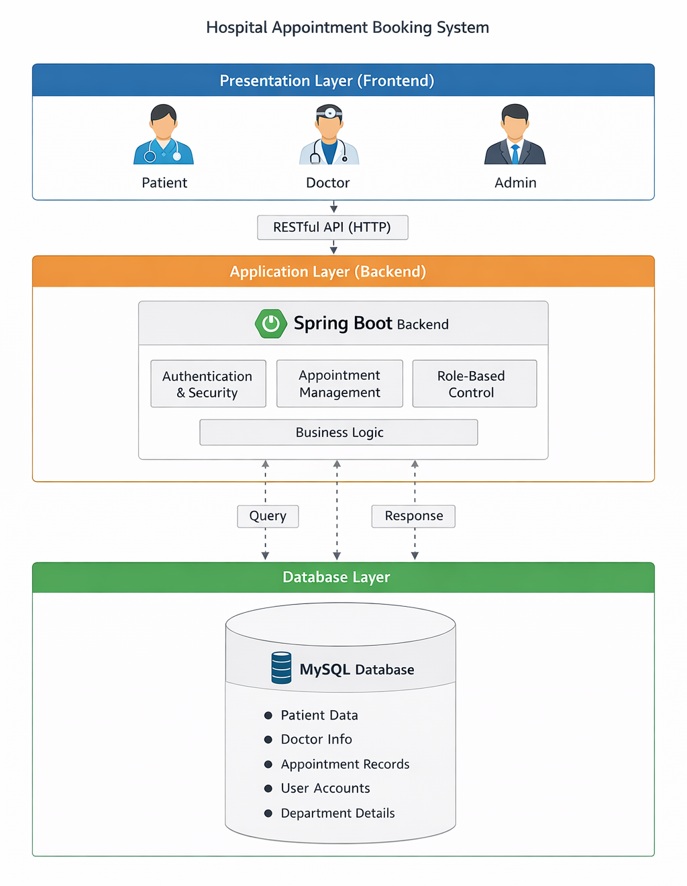

- SYSTEM FLOW DIAGRAM

The System Flow Diagram (SFD) represents the logical flow of activities performed by different users in the Hospital Appointment Booking System. It explains how data and control move from one step to another during the appointment booking process. By visualizing the flow of information, the diagram helps stakeholders understand the working of the system in a clear and structured manner. It also highlights the interactions between patients, doctors, and administrators, ensuring that the system’s processes are transparent and easy to follow.

  - Purpose of the System Flow Diagram
The main purpose of the System Flow Diagram is to:
- Provide a visual representation of how the system operates.
- Show the sequence of actions performed by different users.
- Illustrate the movement of data between components.
- Identify decision points where the system validates or processes information.
- Help developers, hospital staff, and management understand the end-to-end workflow of appointment booking.

By mapping out the flow, the diagram serves as a blueprint for both system design and user training.

  - Key Actors in the System Flow
The Hospital Appointment Booking System involves three primary actors:
- Patients: End-users who book appointments online, view schedules, and receive notifications.
- Doctors: Healthcare providers who manage their schedules, view patient details, and confirm appointments.
- Administrators: Hospital staff responsible for overseeing system operations, managing records, and ensuring smooth workflow.
Each actor interacts with the system differently, and the flow diagram captures these interactions in detail.
  - Logical Flow of Activities

Step 1: Patient Login/Registration
- Patients access the system through a web portal or mobile application.
- New users register by providing personal details, while existing users log in with secure credentials.
- The system validates login information through the backend authentication process.
Step 2: Department and Doctor Selection
- Patients select the department they wish to visit (e.g., cardiology, orthopedics).
- Within the department, patients choose a doctor based on specialization and availability.
- The system fetches doctor schedules from the database.
Step 3: Viewing Available Time Slots
- The system displays real-time appointment slots for the selected doctor.
- Patients can view available dates and times, ensuring transparency in scheduling.
- The backend checks for conflicts to prevent overlapping appointments.
Step 4: Appointment Booking
- Patients confirm their preferred time slot.
- The system validates the booking request and updates the database.
- A confirmation message is sent to both the patient and the doctor.
Step 5: Notifications and Reminders
- The system automatically generates notifications for patients and doctors.
- Patients receive reminders via email or SMS to reduce missed appointments.
- Doctors are notified of upcoming consultations to prepare in advance.
Step 6: Doctor Interaction
- Doctors log in to view their schedules and patient details.
- They can confirm, reschedule, or cancel appointments if necessary.
- Updates are reflected in real time, ensuring accurate records.
Step 7: Administrator Oversight
- Administrators monitor appointment trends and hospital workflow.
- They can generate reports, manage user accounts, and resolve scheduling conflicts.
- The system provides dashboards for efficient management.
  - Data Flow in the System
The flow of data is critical to the functioning of the system:
- Patient Data: Stored securely in the database, linked to appointment records.
- Doctor Data: Includes schedules, specialization, and availability.
- Appointment Data: Captures booking details, time slots, and status updates.
- System Logs: Maintain records of user activities for auditing and troubleshooting.
Data moves seamlessly between the frontend (user interface), backend (application logic), and database (storage), ensuring accuracy and reliability.

  - Benefits of the System Flow Diagram

- Clarity: Provides a clear understanding of how the system operates.
- Efficiency: Identifies redundant steps and helps optimize workflows.
- Error Reduction: Highlights validation points to minimize scheduling conflicts.
- Training Tool: Assists hospital staff and patients in learning how to use the system.
- Development Aid: Guides software developers in implementing features correctly.

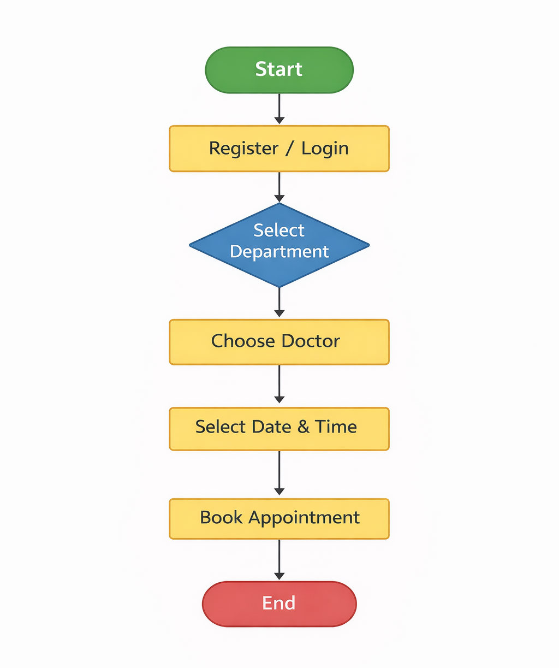

- ENTITY RELATIONSHIP (ER) DIAGARAM

The Entity Relationship (ER) Diagram represents the data model of the Hospital Appointment Booking System. It shows the entities involved in the system and the relationships between them. The ER diagram is a crucial tool in database design because it provides a clear visualization of how data is stored, related, and managed. By mapping out entities and their relationships, the diagram ensures that the system’s database structure is logical, efficient, and capable of supporting the hospital’s operational needs.

11.1 Purpose of the ER Diagram
The ER diagram serves several important purposes:

- Data Modeling: It defines the structure of the database by identifying entities, attributes, and relationships.
- Clarity: It provides a visual representation of how different components of the system interact.
- Efficiency: It helps developers design a database that avoids redundancy and ensures data integrity.
- Communication: It acts as a bridge between technical developers and non-technical stakeholders, making it easier to explain how the system works.
- Foundation for Implementation: It guides the creation of tables, keys, and constraints during database development.

11.2 Key Entities in the System
The Hospital Appointment Booking System involves several core entities, each representing a major component of the hospital’s operations:

1. Patient
- Attributes: Patient_ID, Name, Age, Gender, Contact Information, Address, Login Credentials.
- Role: Represents individuals who book appointments and receive healthcare services.
2. Doctor
- Attributes: Doctor_ID, Name, Specialization, Department, Contact Information, Schedule.
- Role: Represents healthcare providers who manage consultations and appointments.
3. Appointment
- Attributes: Appointment_ID, Date, Time, Status (Confirmed, Cancelled, Rescheduled).
- Role: Represents the booking details between patients and doctors.
4. Department
- Attributes: Department_ID, Department_Name, Description.
- Role: Represents hospital departments such as cardiology, orthopedics, pediatrics, etc.
5. Administrator
- Attributes: Admin_ID, Name, Role, Login Credentials.
- Role: Represents hospital staff responsible for managing system operations and ensuring smooth workflow.

11.3 Relationships Between Entities
The ER diagram highlights the relationships between these entities:
- Patient → Appointment: A patient can book multiple appointments, but each appointment is linked to a single patient.
(One-to-Many relationship)
- Doctor → Appointment: A doctor can attend multiple appointments, but each appointment is linked to one doctor.
(One-to-Many relationship)
- Department → Doctor: Each department can have multiple doctors, but each doctor belongs to one department.
(One-to-Many relationship)
- Administrator → System Management: Administrators oversee the entire system, managing patients, doctors, and appointments.
(One-to-Many relationship with multiple entities)

11.4 Logical Flow of Data in the ER Model
The ER diagram ensures that data flows logically across the system:
- Patient Registration: Patient details are stored in the Patient entity.
- Doctor Assignment: Doctors are linked to departments, ensuring specialization is recorded.
- Appointment Scheduling: Appointments connect patients and doctors, with time slots stored in the Appointment entity.
- System Oversight: Administrators monitor and manage all entities, ensuring data accuracy and workflow efficiency.
11.5 Advantages of the ER Diagram
- Data Integrity: Relationships prevent duplication and ensure consistency.
- Scalability: The model can easily accommodate new entities, such as billing or laboratory records.
- Security: Role-based access can be implemented based on entities and relationships.
- Efficiency: Queries can be optimized by understanding how entities are connected.
- Clarity: Provides a structured view of hospital operations, making it easier to train staff and explain workflows.
11.6 Example ER Diagram Description (Textual)
Since I cannot display the actual diagram here, imagine the following structure:
- Patient (Patient_ID, Name, Contact)
- linked to Appointment (Appointment_ID, Date, Time, Status)
- linked to Doctor (Doctor_ID, Name, Specialization)
- linked to Department (Department_ID, Department_Name)
- Administrator (Admin_ID, Role) oversees all entities.
This textual description can be easily converted into a graphical ER diagram using tools like MySQL Workbench, Lucidchart, or Microsoft Visio.

11.6 Entities

Patient  - Patient_ID (Primary Key)  - Name  - Age  - Gender  - Contact Number  - Email  - Username  - Password | Doctor  - Doctor_ID (Primary Key)  - Name  - Specialization  - Department  - Contact Number  - Availability
Appointment  - Appointment_ID (Primary Key)  - Appointment Date  - Time Slot  - Status  - Patient_ID (Foreign Key)  - Doctor_ID (Foreign Key) | Admin  - Admin_ID (Primary Key)  - Username  - Password  - Role

11.7 Relationships
The relationships in the Hospital Appointment Booking System define how different entities interact with one another. These relationships are crucial for ensuring that the database structure is logical, efficient, and capable of supporting hospital operations. By clearly identifying the connections between patients, doctors, administrators, and appointments, the system can maintain data integrity, avoid redundancy, and streamline workflows. Below is a detailed explanation of the key relationships.

1. Patient → Appointment (One-to-Many)
A one-to-many relationship exists between the Patient and Appointment entities. This means that a single patient can book multiple appointments over time, but each appointment record belongs to only one patient.

- Example: A patient named John may book appointments with a cardiologist on Monday and an orthopaedist on Friday. Both appointments are linked to John’s patient ID, ensuring that his medical history and schedule are accurately maintained.
- Importance:
  - Allows patients to manage multiple consultations.
  - Ensures that appointment records are tied to the correct patient.
  - Facilitates retrieval of patient history for doctors and administrators.
- Database Implication: The Appointment table will contain a foreign key referencing the Patient_ID, ensuring that each appointment is uniquely associated with one patient.

2. Doctor → Appointment (One-to-Many)
A one-to-many relationship also exists between the Doctor and Appointment entities. A single doctor can handle multiple appointments, but each appointment is assigned to only one doctor.

- Example: Dr. Smith, a cardiologist, may have ten appointments scheduled in a single day. Each appointment record is linked to Dr. Smith’s doctor ID, ensuring that his schedule is properly managed.
- Importance:
  - Helps doctors organize their daily schedules.
  - Prevents scheduling conflicts by linking appointments directly to doctors.
  - Provides transparency for patients when selecting available time slots.
- Database Implication: The Appointment table will contain a foreign key referencing the Doctor_ID, ensuring that each appointment is tied to a specific doctor.

3. Admin → System Management
The Administrator entity has a broad relationship with the system, overseeing doctors, patients, departments, and appointments. Unlike the one-to-many relationships above, this is more of a control relationship, where administrators manage and monitor multiple entities simultaneously.

- Example: An administrator may add new doctors to the system, update patient records, assign doctors to departments, and resolve scheduling conflicts.
- Importance:
  - Ensures smooth hospital workflow.
  - Provides centralized control over system operations.
  - Allows administrators to generate reports and monitor hospital performance.
- Database Implication: The admin entity interacts with multiple tables (Patient, Doctor, Appointment, Department), ensuring that administrators have the authority to update, delete, or manage records as needed.

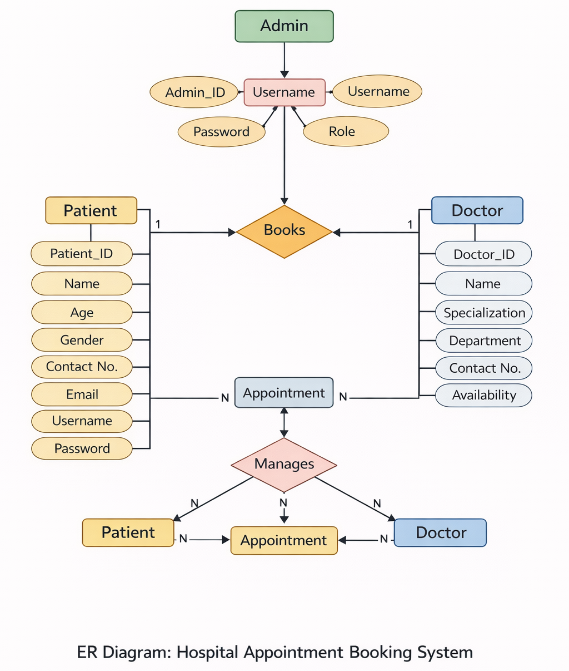

- DATABASE DESIGN

The database design plays a crucial role in ensuring efficient data storage, retrieval, and management in the Hospital Appointment Booking System. The system uses a relational database model, where data is organized into tables with proper relationships using primary keys and foreign keys. This design ensures data integrity, consistency, and avoids redundancy.

12.1 Patient Table
The Patient table stores all patient-related information required for authentication and appointment booking.

Column Name | Data Type | Description
id | Long | Primary key, uniquely identifies a patient
first_name | String | Patient’s first name
last_name | String | Patient’s last name
username | String | Unique username for login
password | String | Encrypted password
phone | String | Contact number

12.2 Doctor Table
The Doctor table contains details of doctors available in the hospital.

Column Name | Data Type | Description
id | Long | Primary key, uniquely identifies a doctor
name | String | Doctor’s name
department | Enum | Medical department (e.g., Cardiology)
phone | String | Contact number

12.3 Appointment Table
The Appointment table stores appointment-related information and acts as a linking table between Patient and Doctor.

Column Name | Data Type | Description
id | Long | Primary key
patient_id | FK | Foreign key referencing Patient table
doctor_id | FK | Foreign key referencing Doctor table
date | String | Appointment date
time | String | Appointment time slot
status | Enum | Appointment status (Booked, Completed, Cancelled)

- MODULE DESCRIPTION

The system is divided into multiple modules based on user roles. Each module performs specific operations to ensure smooth functioning of the system.

13.1 Admin Module
The admin module provides complete control over the system.
Functions:
- Admin Login
- View of registered doctors
- View of registered patients
- View all appointments
- Monitor system activities
This module ensures proper system supervision and management.

13.2 Patient Module
The Patient module allows patients to interact with the system and manage their appointments.
Functions:
- Patient registration and login
- Book appointments based on doctor availability
- View appointment history
- Cancel appointments
This module improves patient convenience by enabling online appointment booking.

13.3 Doctor Module
The Doctor module helps doctors manage their schedules efficiently.
Functions:
- Doctor registration and login
- View scheduled appointments
- Update appointment status (Completed / Cancelled)
This module helps doctors manage patient flow and consultation timing.

- TECHNOLOGY STACK

The Hospital Appointment Booking System is developed using modern web technologies to ensure scalability, security, and performance.

Layer | Technology
Frontend | Angular, Bootstrap
Backend | Java, Spring Boot
Database | H2 / MySQL
Tools | Visual Studio Code, Postman

- API DESIGN (SAMPLE)

The system follows a RESTful API architecture, allowing smooth communication between frontend and backend.
Sample APIs:
- POST /hospital/appointments/book → Used to book a new appointment
- GET /hospital/appointments/slots → Fetch available appointment slots
- GET /hospital/doctors/by-department → Retrieve doctors based on department
These APIs ensure modularity and easy integration.

- USER INTERGACE DESIGN

The user interface is designed to be simple, intuitive, and user-friendly. Angular and Bootstrap are used to create responsive and visually appealing pages.
16.1 Home Page
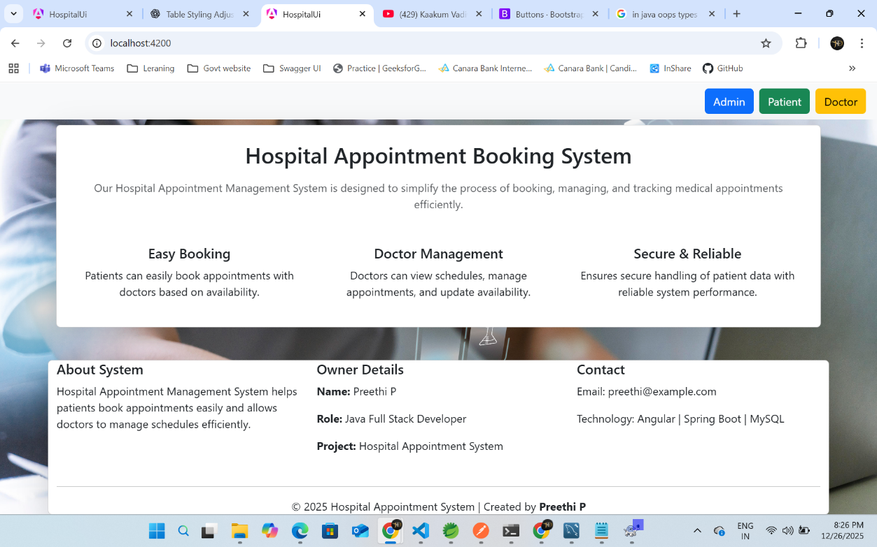

16.2 Admin Dashboard
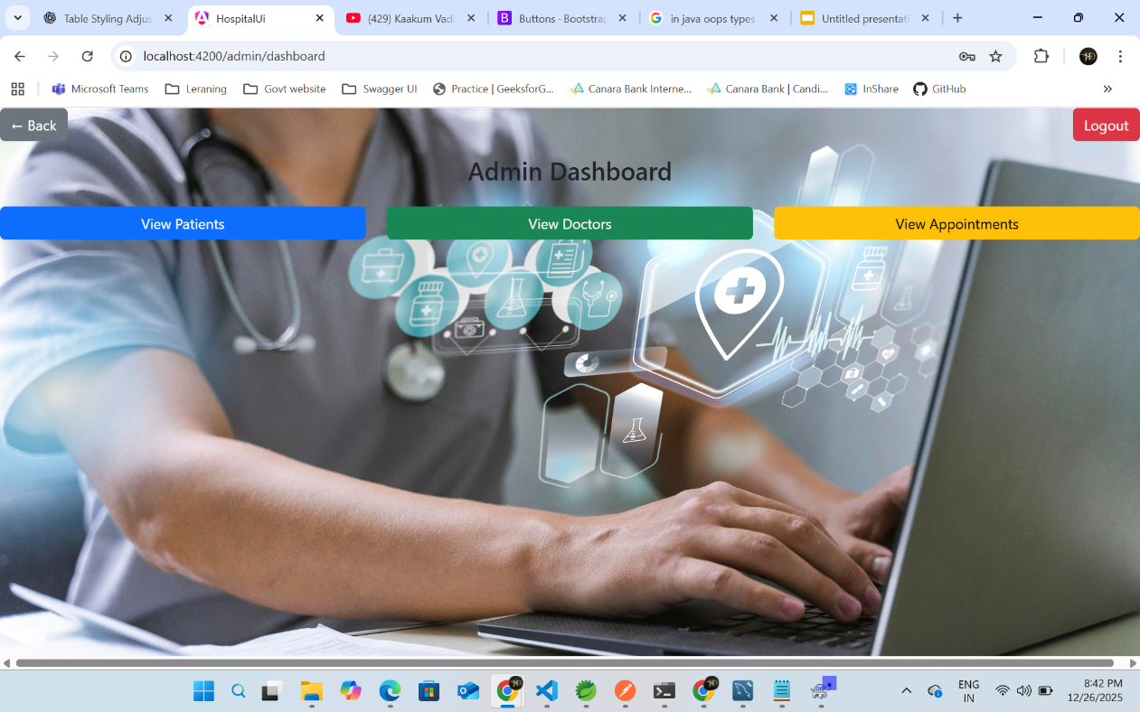
16.3 Patient Dashboard
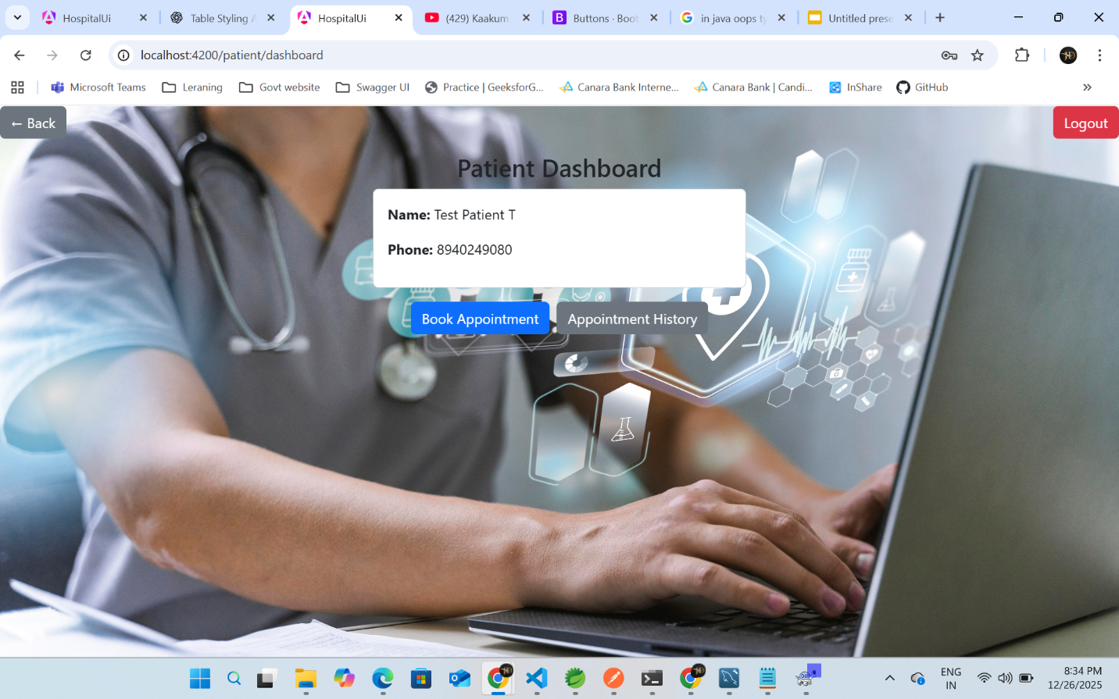

16.4 Patient Book Appointment
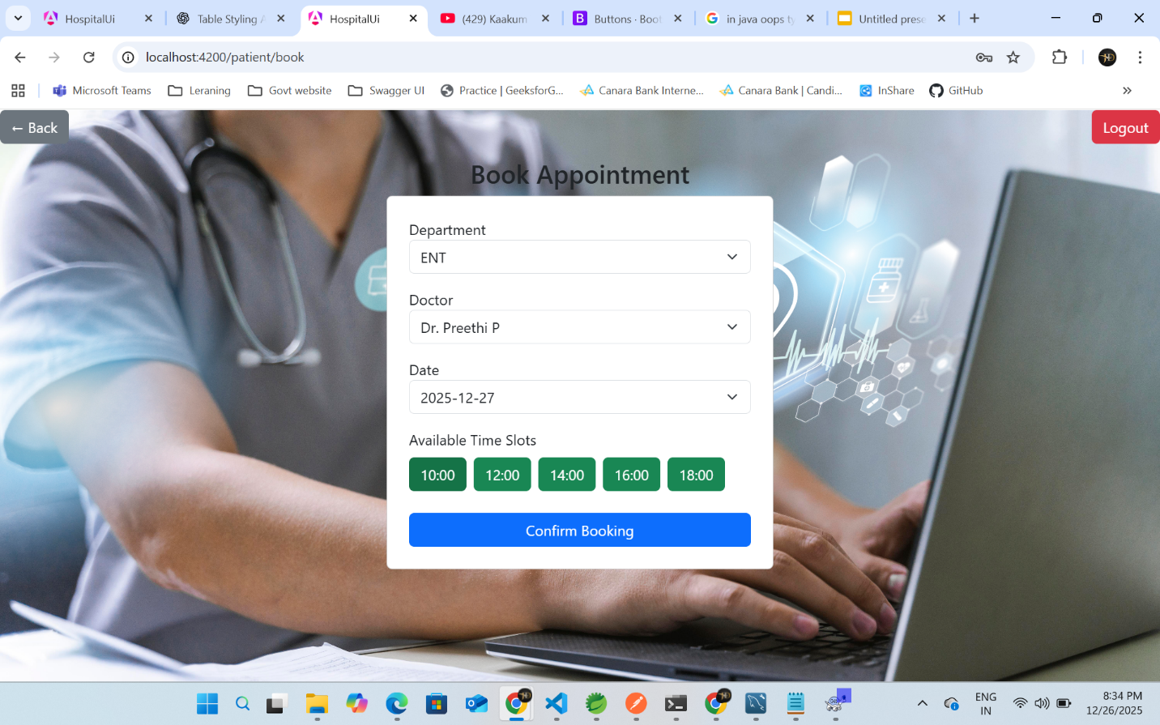
16.5 Patient Appointment History
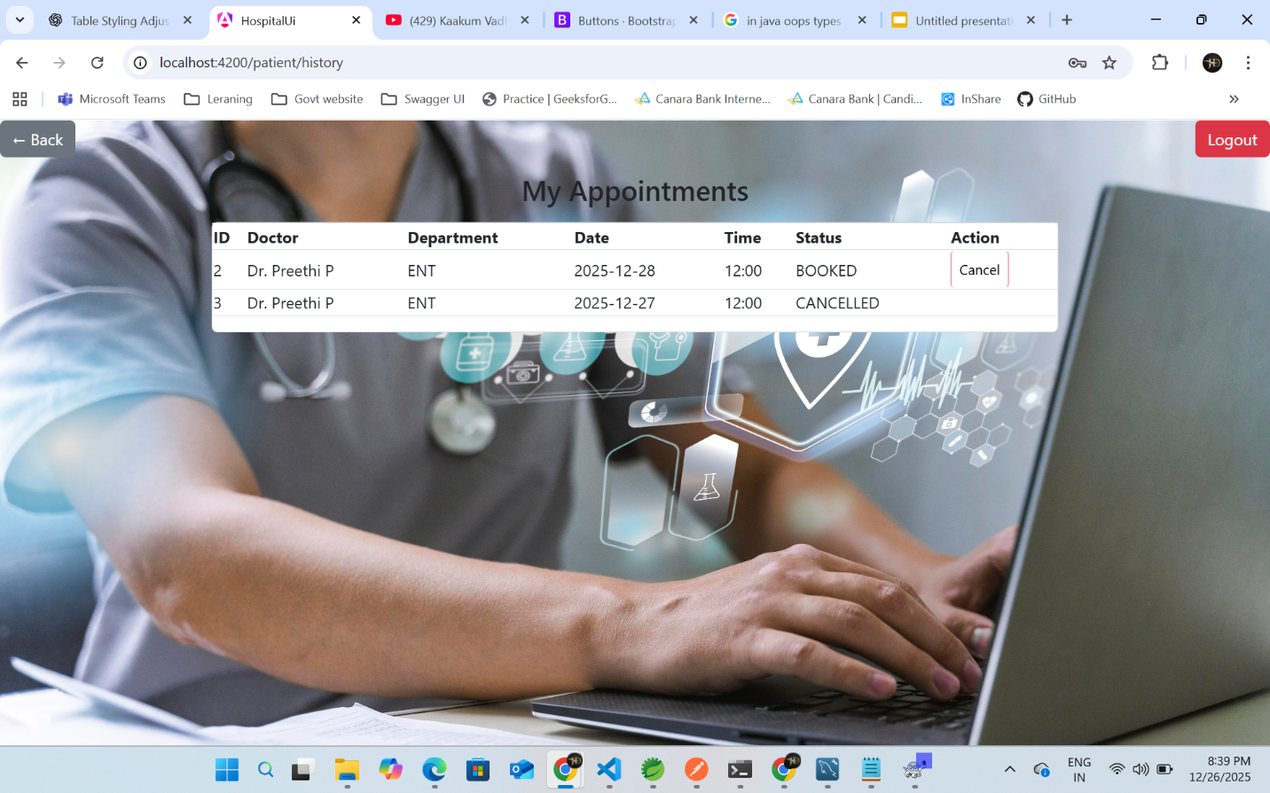

16.6 Doctor Dashboard
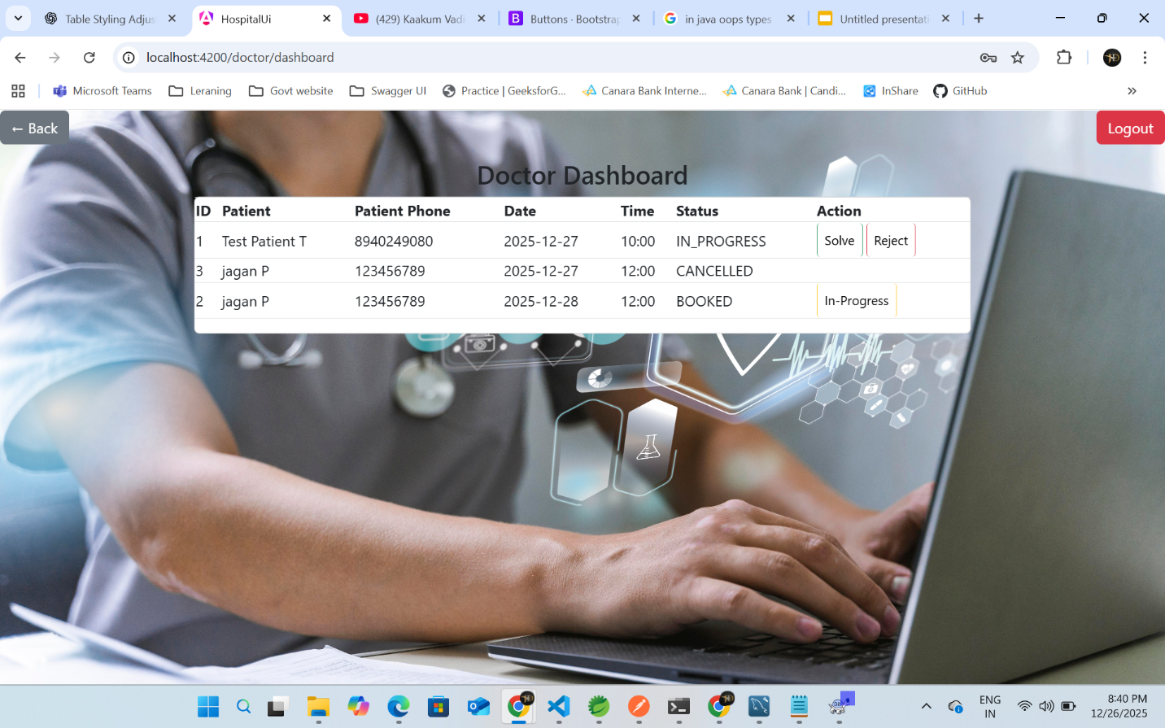
- TESTING

Testing is one of the most critical phases in the software development lifecycle. It ensures that the system functions as intended, meets user requirements, and operates reliably under different conditions. For the Hospital Appointment Booking System, testing was carried out systematically using multiple techniques to identify defects, validate functionality, and guarantee a smooth user experience. The testing process covered individual modules, integrated workflows, APIs, and the user interface, ensuring that the system was robust, secure, and user-friendly.

17.1 Unit Testing
Unit testing focused on verifying the correctness of individual modules and components. Each function was tested independently to confirm that it produced the expected output for valid inputs and handled invalid inputs gracefully.
- Patient Registration Module:
- Tested for accurate data entry, validation of mandatory fields (e.g., name, age, contact details), and prevention of duplicate registrations. For example, the system was checked to ensure that two patients could not register with the same email ID.
- Doctor Management Module:
- Verified that doctors could be added, updated, or removed correctly. Tests ensured that specialization, availability, and contact details were stored accurately in the database.
- Appointment Booking Module:
- Tested for correct slot allocation, prevention of overlapping appointments, and proper handling of cancellations or rescheduling.
Unit testing helped isolate errors early in development, reducing the cost and complexity of fixing issues later. Automated test cases were also written to repeatedly validate core functionalities whenever new code was introduced.

17.2 Integration Testing
Once individual modules were validated, integration testing was conducted to ensure smooth interaction between different components.
- Frontend–Backend Communication:
- Verified that data entered on the Angular frontend was correctly transmitted to the Spring Boot backend and stored in the database. For example, when a patient booked an appointment, the booking details were checked to ensure they appeared correctly in both the patient dashboard and the doctor’s schedule.
- Database Connectivity:
Ensured that queries executed by the backend retrieved and updated records accurately. Tests confirmed that patient details, doctor availability, and appointment schedules were synchronized across modules.
- Cross-Module Workflows:
For instance, when a patient registered and booked an appointment, the system was tested to confirm that the doctor’s dashboard reflected the new booking and the administrator’s panel updated the hospital schedule accordingly.
Integration testing validated that the system worked seamlessly as a whole, eliminating issues such as data mismatches, broken workflows, or communication errors between modules.

17.3 API Testing Using Postman
Since the system relied heavily on RESTful APIs for communication between frontend and backend, API testing was a crucial step. Postman was used to validate request handling, response correctness, and error management.
- GET Requests:
- Tested retrieval of patient records, doctor availability, and appointment schedules. For example, a GET request for a doctor’s schedule was checked to ensure that only the correct appointments were returned.
- POST Requests:
- Verified that new patient registrations and appointment bookings were correctly inserted into the database.
- Error Handling:
- Tested scenarios such as invalid inputs, unauthorized access, or unavailable resources. For instance, if a patient attempted to book a slot that was already taken, the API was expected to return a clear error message rather than crashing.
- Response Validation:
- Ensured that responses were consistent, properly formatted (JSON), and contained accurate data.
API testing guaranteed reliable communication between system components and ensured that external integrations could be supported in the future.

17.4 User Interface Testing
User interface (UI) testing was conducted to evaluate usability, navigation, and responsiveness. Since the system was designed to be patient-centric, ensuring a smooth and intuitive user experience was essential.
- Usability:
- Tested whether patients could easily register, log in, and book appointments without confusion. Buttons, forms, and navigation menus were checked for clarity and accessibility.

Responsiveness
Verified that the application worked across different screen sizes and resolutions, including desktops, tablets, and mobile devices. For example, the appointment booking calendar was tested to ensure it displayed correctly on smaller screens.
- Consistency:
- Ensured that design elements such as fonts, colors, and layouts were uniform across all pages. This helped maintain a professional and user-friendly appearance.
- Accessibility:
- Tested features like error messages, form validations, and navigation shortcuts to ensure that even users with limited technical knowledge could interact with the system effectively.
UI testing confirmed that the system delivered a consistent, reliable, and user-friendly experience, which is critical in healthcare environments where patients may be stressed or unfamiliar with technology

- ADVANTAGES
The Hospital Appointment Booking System delivers a wide range of benefits to hospitals, doctors, and patients by addressing the inefficiencies of traditional manual scheduling methods. By leveraging modern web technologies, the system enhances convenience, accuracy, and overall healthcare service delivery. The following points provide a comprehensive explanation of its advantages:

18.1 Timesaving for Patients
One of the most significant advantages is the ability for patients to book appointments online at any time, without physically visiting the hospital. This saves considerable time, especially for elderly individuals, patients with mobility challenges, or those living in remote areas. Instead of waiting in long queues, patients can quickly select available slots and confirm their appointments from home. This convenience improves patient satisfaction and encourages timely medical consultations. For patients with chronic illnesses who require frequent visits, the system reduces repetitive administrative tasks and ensures smoother access to healthcare.

18.2 Reduced Administrative Workload
Hospital staff traditionally spend hours managing registers, verifying patient details, and resolving scheduling conflicts. The automated system reduces this burden by digitizing appointment records and streamlining workflows. Receptionists and administrators no longer need to manually update schedules or maintain paper files, allowing them to focus on more critical tasks such as patient support and hospital operations. This reduction in workload also minimizes human error and improves efficiency. Automated reporting features further assist administrators in monitoring hospital performance without the need for manual data compilation.

18.3 Improved Hospital Workflow Efficiency
Doctors and hospital staff benefit from clear visibility into daily schedules. The system provides real-time updates on patient bookings, cancellations, and rescheduling, ensuring that doctors can plan their consultations effectively. This organized workflow prevents overcrowding in waiting areas, balances patient distribution across time slots, and enhances overall hospital productivity. By reducing confusion and delays, hospitals can deliver smoother and more reliable healthcare services. Doctors can also prepare in advance for consultations, improving the quality of care provided.

18.4 Minimization of Appointment Conflicts
Manual systems often suffer from overlapping appointments or double bookings due to human error. The proposed system eliminates these issues by displaying real-time slot availability and automatically preventing conflicts. Patients can only book available slots, and doctors are notified instantly of new appointments. This ensures that schedules remain accurate and consistent, reducing frustration for both patients and healthcare providers. The system also supports rescheduling and cancellation tracking, ensuring that freed-up slots can be reallocated efficiently.

18.5 User-Friendly Interface
The system is designed with a simple, intuitive interface that makes it easy for patients to navigate. Even individuals with limited technical knowledge can register, log in, and book appointments without difficulty. Features such as clear menus, responsive design, and accessible layouts ensure that the platform is inclusive and usable across devices, including desktops, tablets, and smartphones. A user-friendly interface increases adoption rates and enhances the overall patient experience. Doctors and administrators also benefit from dashboards that provide quick access to relevant information, reducing training requirements and improving usability.

18.6 Enhanced Data Security and Accuracy
Sensitive patient information is stored securely in the system’s database, protected by authentication mechanisms and role-based access control. This ensures that only authorized users—patients, doctors, or administrators—can access relevant data. Automated validation checks also improve accuracy, preventing incomplete or incorrect entries. Secure and reliable data management builds trust between patients and hospitals, ensuring compliance with healthcare privacy regulations. Accurate records also support long-term patient care by maintaining consistent medical histories.

18.7 Reduction in Paperwork and Costs
The reduction in paperwork also contributes to By digitizing appointment management, the system eliminates the need for physical registers and paper-based documentation. This reduces storage requirements, minimizes the risk of data loss, and lowers administrative costs. Hospitals save money on printing, filing, and record maintenance, while staff benefit from faster information retrieval. environmental sustainability by minimizing paper consumption.

18.8 Scalability and Future Enhancements
The system is designed to be scalable, meaning it can handle increasing patient volumes without compromising performance. As hospitals grow or expand services, the system can easily accommodate new departments, doctors, and patients. Additionally, the architecture supports future enhancements such as online payments, automated notifications, integration with electronic medical records (EMRs), and advanced analytics. This adaptability ensures that the system remains relevant and valuable in the long term

- LIMITATIONS

Despite the numerous advantages offered by the Hospital Appointment Booking System, it is important to acknowledge that the system also has certain limitations. These limitations highlight areas where the system can be improved in future versions to ensure greater efficiency, security, and usability. Understanding these constraints provides a balanced view of the system’s current capabilities and helps guide future development efforts.

19.1 Dependence on Stable Internet Connection
The system is web-based, which means it requires a stable internet connection to function effectively. In urban areas with reliable connectivity, this may not pose a significant challenge. However, in semi-urban and rural regions where internet access is inconsistent or unavailable, patients may face difficulties in booking appointments online. This limitation restricts accessibility for individuals who do not have regular access to the internet or digital devices. As healthcare services must be inclusive, the reliance on internet connectivity can create a digital divide, leaving certain patient groups underserved. Offline functionality or hybrid models could be explored in future versions to mitigate this issue.

19.2 Absence of Payment Integration
Currently, the system is limited to appointment scheduling and does not support online payment integration. Patients must still rely on traditional methods such as cash or card payments at the hospital. This creates additional steps in the patient journey and reduces the convenience of a fully digital healthcare experience. Payment integration would allow patients to pay consultation fees in advance, reducing queues at billing counters and improving hospital efficiency. The absence of this feature also limits the system’s ability to support telemedicine services, where online payments are essential. Future enhancements could include secure payment gateways, integration with mobile wallets, and support for insurance claims.

19.3 Basic Authentication Mechanisms
The system currently uses basic authentication methods to secure patient and doctor accounts. While this provides a level of protection, it may not be sufficient against advanced cyber threats. Healthcare data is highly sensitive, and weak authentication mechanisms increase the risk of unauthorized access, data breaches, and identity theft. For example, simple username-password combinations may be vulnerable to phishing or brute-force attacks. Stronger security measures such as multi-factor authentication (MFA), biometric verification, and encrypted communication channels should be considered in future versions to enhance data protection and ensure compliance with healthcare privacy regulations.

19.4 Limited to Appointment Management Functionality
The system’s primary focus is appointment scheduling, which means it does not currently support other critical hospital functions such as electronic medical records (EMRs), billing automation, inventory management, or laboratory integration. While this specialization makes the system efficient for its intended purpose, it limits its scope as a comprehensive hospital management solution. Hospitals often require integrated platforms that handle multiple aspects of operations, from patient records to financial management. The absence of these features means that hospitals may need to use additional systems, leading to fragmentation and inefficiencies. Expanding the system to include modules for EMRs, billing, and analytics would make it more versatile and valuable.

19.5 User Adoption Challenges
Although the system is designed to be user-friendly, some patients—particularly elderly individuals or those unfamiliar with technology—may struggle to adopt digital appointment booking. Limited digital literacy can reduce the effectiveness of the system, as patients may still prefer traditional methods such as in-person registration. Hospitals may need to provide training, awareness campaigns, or assisted booking services to encourage adoption. Without such support, the system’s benefits may not reach all patient groups equally

- FUTURE ENHANCEMENTS

The Hospital Appointment Booking System has been designed with scalability and adaptability in mind. While the current version focuses primarily on appointment scheduling, the architecture allows for the integration of advanced features that can further improve security, usability, and accessibility. These enhancements will ensure that the system remains relevant in the rapidly evolving healthcare technology landscape. The following points outline potential future improvements:

20.1 Implementation of JWT-Based Authentication
Security is a critical aspect of healthcare systems, as they handle sensitive patient information. The current system uses basic authentication mechanisms, which, while functional, may not provide the highest level of protection against modern cyber threats. Future versions can incorporate JSON Web Token (JWT)-based authentication, which offers a more secure and scalable approach. JWTs allow for stateless authentication, meaning that user sessions can be validated without storing session data on the server. This reduces server load and enhances performance. Additionally, JWTs can be encrypted and signed, ensuring that data exchanged between clients and servers is tamper-proof. By implementing JWT authentication, the system can provide stronger protection against unauthorized access, identity theft, and data breaches, thereby complying with healthcare privacy regulations such as HIPAA.

20.2 Email and SMS Notifications
Timely communication is essential in healthcare environments. Future versions of the system can include automated email and SMS notifications to confirm appointments, send reminders, and notify patients of cancellations or rescheduling. This feature would reduce no-show rates, improve patient punctuality, and enhance overall hospital efficiency. For example, patients could receive a reminder one day before their appointment, along with details such as the doctor’s name, department, and time slot. Doctors could also be notified of last-minute changes to their schedules, allowing them to adjust accordingly. Notifications can be customized to suit patient preferences, ensuring a more personalized and reliable communication channel.

20.3 Integration of Online Payment Gateway
Currently, the system does not support online payments, requiring patients to pay consultation fees at the hospital. Future enhancements can include integration with secure online payment gateways, enabling patients to pay in advance while booking appointments. This would streamline the billing process, reduce queues at payment counters, and improve hospital workflow. Payment integration can also support telemedicine services, where online consultations require digital transactions. By incorporating multiple payment options such as credit/debit cards, mobile wallets, and UPI, the system can cater to diverse patient needs. Additionally, integration with insurance providers could allow patients to process claims directly through the platform, further enhancing convenience.

20.4 Development of a Mobile Application
Accessibility is a key factor in ensuring widespread adoption of digital healthcare solutions. While the current system is web-based, future versions can include a dedicated mobile application for Android and iOS devices. A mobile app would provide patients with greater flexibility, allowing them to book appointments, receive notifications, and access medical records on the go. Mobile applications are particularly useful for patients in rural areas, where smartphones are often more accessible than desktop computers. Features such as push notifications, biometric login, and offline appointment viewing can further enhance usability. For doctors and administrators, the mobile app can provide dashboards for quick access to schedules and patient information, improving efficiency and responsiveness.

20.5 Integration with Electronic Medical Records (EMRs)
Beyond appointment scheduling, future versions can integrate with electronic medical records (EMRs) to provide a more comprehensive healthcare management solution. This would allow doctors to access patient histories directly during consultations, improving the quality of care. Patients could also view their medical records, prescriptions, and test results through the system, reducing the need for physical documentation. EMR integration would enhance continuity of care, support better decision-making, and ensure that patient data is consistently updated across departments.

20.6 Advanced Analytics and Reporting
Hospitals can benefit greatly from data-driven insights. Future enhancements may include analytics and reporting modules that track appointment trends, patient demographics, doctor workloads, and hospital efficiency. Administrators could use these reports to identify bottlenecks, optimize resource allocation, and improve service delivery. Predictive analytics could also help forecast patient demand, enabling hospitals to plan staffing and resources more effectively

- CONCLUSION

The Hospital Appointment Booking System successfully automates the appointment scheduling process and addresses the challenges of traditional manual systems.
- Improves hospital efficiency.
- Reduces patient waiting time.
- Ensure accurate data management.
- Provides scalable architecture, secure design, and user-friendly interface.
The system is well-suited for real-world healthcare environments and can be further enhanced to meet evolving requirements.

- REFERENCES

- Spring Boot Documentation
- Angular Official Documentation
- Oracle Java Documentation
- Bootstrap Documentation

